SSG Justin Vasquez
Memorial Scholarship
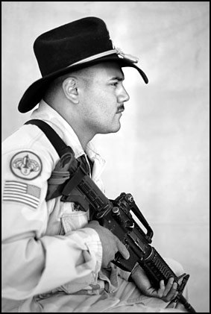
Staff Sergeant Justin Vasquez, 26, native of Manzanola, was killed during his second tour in Iraq on June 5th, 2005 by an IED while leading his men south of Baghdad. He was a 1997 graduate of Manzanola High School.

The SSG Justin Vasquez Memorial Scholarship Fund was formed to honor one that gave the ultimate sacrifice for his country. The family wishes to assist graduating high school seniors in becoming productive and contributing participants in their community. Additionally, the family believes in the importance of attaining an education and the necessity of having high standards of work ethics. Thus, these esteemed values are passed on to the succeeding generations.

Since 2006, two $500 scholarships have been awarded each year to graduating seniors. The family has continued to organize yearly events to help the scholarship fund grow. The family is proud to announce that in 2010, three $500 scholarships were awarded.

Eligibility:
- Must be a resident of the state of Colorado
- Must have maintained a GPA (grade point average) of 2.5 on a 4.0 scale during high school

Requirements:
- Student Application form (attached)
- Student Achievement form (attached). Students are allowed to use a separate sheet to include all student achievements.
- At least a one-page, single spaced typed essay on the subject “My Responsibility To America.”
(Not to exceed three pages)
- Three letters of recommendation: two letters from teachers and one letter from another person. The typed recommendations should include the name of the individual writing the recommendation, their signature, their title and date. The recommendation should provide information on the student’s specific accomplishments (academic/non-academic) and evidence of the student’s leadership and motivation.

Payment:
The recipient will receive a cashier’s check for $500.

Deadline:
Applications must be postmarked by April 20th. Mail to:

Jennifer Vasquez Arebalo
600 S 10th
Rocky Ford, CO 81067
(719) 469-3148.

Student Application

Name:_________________________________________________________________________
Last First Middle

Address:_______________________________________________________________________
Mailing Address City State Zip

Date of Birth:______________ Phone Number(s):_____________________________________

College/School you are plan to attend:________________________________________________

_______________________________________________________________________________
Univeristy/College Address City State Zip

Course Of Study:________________________________________________________

Current High School:_____________________________________________________

High School Accumulative GPA:_____________ Shirt Size: ______________

I hereby certify, to the best of my knowledge, that all of the information submitted by me is current, complete and my own. By submitting this application, I authorize my high school/college counselor to make available to the SSG Justin Vasquez Memorial Scholarship members information concerning my academic records.

Student Signature:_______________________________________ Date:_____________

High School Counselor
Use Only

I hereby certify that the academic information represented above is correct.

Printed Name:________________________________ Phone Number:_____________

Signature: __________________________________ Date:______________________

Student Achievements

All scholarship applicants must complete this section. The application should be printed clearly or typed. Please do not exceed one page.

- School Activities & Offices Held

- Honors/Awards

- Community Service Work

- Employment History

- Other

